DATABASE
Question # 1.
Using Figure 1 – The Human Resources (HR) Schema Entity Relationship Diagram, please answer the following questions

Figure 1 – The HR Schema
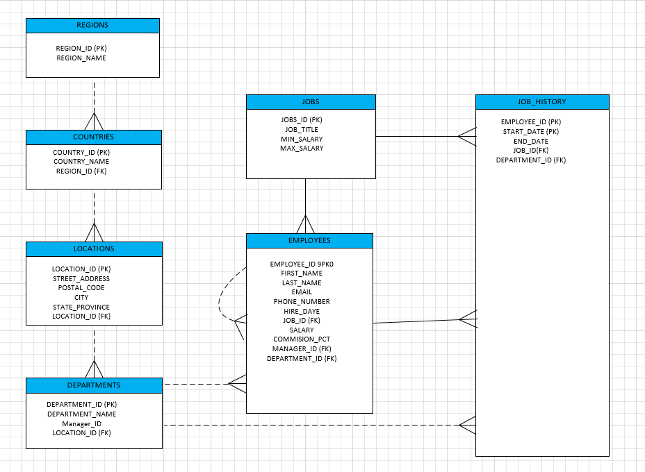

- Looking at the HR Schema, there are six (6) principal business rules that exits within the HR applications. List each one of the six principal business rules.
Note: Solid lines represent mandatory foreign keys (FK) constraints and dashed lines represent optional foreign key (FK) constraints

1).
2).

3).
4).
5).
6).

